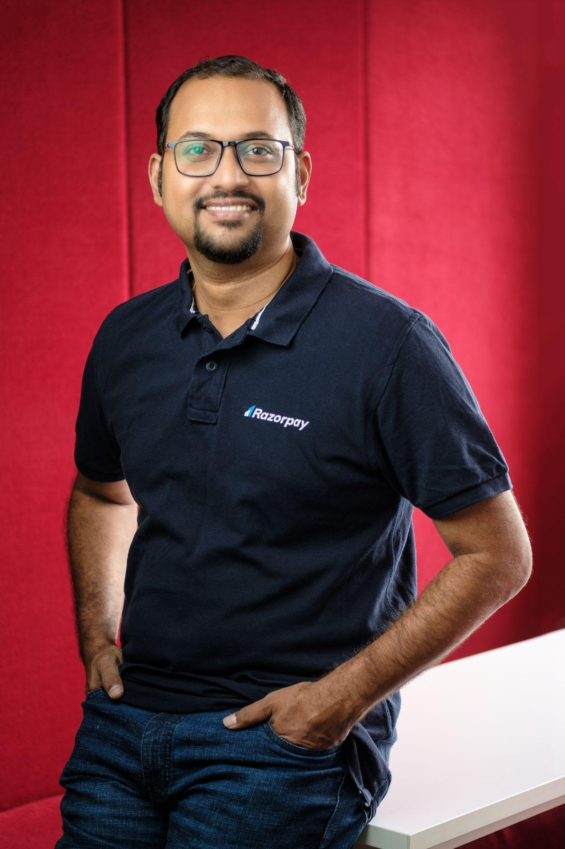

**Murali Brahmadesam**

**CTO & Head - Engineering, Razorpay**

Murali Brahmadesam is the Head of Engineering & Chief Technology Officer at Razorpay. As the CTO, Murali’s role is a critical one that steers the company’s technology, engineering, and innovation strategies, aligning them with business goals. He is responsible for driving the overall engineering strategy and development at Razorpay while driving the stellar growth of Razorpay Engineering.

A veteran with more than two decades of experience, Murali brings together in-depth knowledge of managing diverse technology functions at scale. Prior to this role, he spent a major share of his career at Amazon & Microsoft, working in India & the USA where he has held several technology and leadership roles.

Murali holds an MS degree in Computer Science from the University of Florida and has also completed his Bachelors in Engineering from NIT, Tiruchirappalli.